New Relic AI Monitoring Setup Guide

monitoring for your applications using New Relic, Docker required!
Table of Contents
- What You'll Learn
- Step 1: Create New Relic Account
- Step 2: Install New Relic Integration
- Step 3: Deploy Your Applications
- Step 4: Verify Everything Works

What You'll Learn
By the end of this guide, you'll have:
- A complete monitoring setup for your AI applications
- Real-time insights into application performance and AI model behavior
- Distributed tracing to track requests across services
- Log aggregation for centralized debugging
- Database monitoring for PostgreSQL performance
What is New Relic?
New Relic is a monitoring platform that helps you understand how your applications are performing. Think of it as a health dashboard for your software - it shows you when things are slow, when errors occur, and helps you fix problems quickly.

Step 1: Create Your New Relic Account

Setting Up Monitoring

Create Your Account (Free Account)
- Visit New Relic signup page
- Sign up for a free account (no credit card required)
- Verify your email address
- Choose your data region (US or EU)

What You Get FREE
- Complete AI monitoring for ML/AI applications

- Full NRQL (New Relic Query Language) access

- Advanced querying and dashboard capabilities

- Distributed tracing across microservices

- Real-time AI model performance metrics

- Token usage and cost tracking

- LLM conversation flow analysis

Get Your License Key
- Log into New Relic
- Navigate to: Account Settings -> API Keys
- Look for "Ingest - License" key
- Copy the key (keep it secret!)

Set Environment Variables
# Replace YOUR_KEY_HERE with your actual license key
export NR_LICENSE_KEY="YOUR_KEY_HERE"
export CLUSTER_NAME="my-first-cluster"

# Make these permanent by adding to ~/.bashrc
echo 'export NR_LICENSE_KEY="YOUR_KEY_HERE"' >> ~/.bashrc
echo 'export CLUSTER_NAME="my-first-cluster"' >> ~/.bashrc
source ~/.bashrc
Security Warning:
Never commit your license key to version control (git). Keep it secure and private.

Step 2: Install New Relic Kubernetes Integration

Connect Your Cluster to New Relic
cd deployment/newrelic

Create Configuration File (refer AI monitoring < New Relic and Introduction to AI monitoring | New Relic Documentation)
Create a file called values.yaml with the following content sample:
Note: This folder already contains a values.yaml.sample file. Rename it to values.yaml, then open it and replace the placeholder with your New Relic license key
# values.yaml - New Relic Configuration
global:
licenseKey: # Will be set via environment variable
cluster: my-cluster
lowDataMode: true # Reduces data usage for learning

newrelic-infrastructure:
privileged: true # Required for full monitoring

# Enable specific monitoring features
kube-state-metrics:
enabled: true

newrelic-logging:
enabled: true

newrelic-pixie:
enabled: false # Disable for now (advanced feature)

Add New Relic Helm Repository
helm repo add newrelic https://helm-charts.newrelic.com
helm repo update

Install New Relic Bundle
# Install the monitoring bundle
helm upgrade --install newrelic-bundle newrelic/nri-bundle \
--namespace newrelic --create-namespace
-f values.yaml

Verify Installation
# Check if pods are running
kubectl get pods -n newrelic
NAME READY STATUS RESTARTS AGE
newrelic-bundle-k8s-agents-operator-55cd778f67-7lm9s 1/1 Running 0 67s
newrelic-bundle-kube-state-metrics-6ffbb6cfb6-z79qn 1/1 Running 0 67s
newrelic-bundle-newrelic-logging-5g784 1/1 Running 0 67s
newrelic-bundle-newrelic-prometheus-agent-0 1/1 Running 0 67s
newrelic-bundle-nri-kube-events-65fb59f9-d6xx6 2/2 Running 0 67s
newrelic-bundle-nri-metadata-injection-6cfc7f554d-777pd 1/1 Running 0 67s
newrelic-bundle-nrk8s-controlplane-lbrzz 2/2 Running 0 67s
newrelic-bundle-nrk8s-ksm-9f8d8f656-nrjkt 2/2 Running 0 67s
newrelic-bundle-nrk8s-kubelet-t2qxh 2/2 Running 0 67s
# Check daemonsets
kubectl get daemonsets -n newrelic
NAME DESIRED CURRENT READY UP-TO-DATE AVAILABLE NODE SELECTOR AGE
newrelic-bundle-newrelic-logging 1 1 1 1 1 <none> 81s
newrelic-bundle-nrk8s-controlplane 1 1 1 1 1 kubernetes.io/os=linux 81s
newrelic-bundle-nrk8s-kubelet 1 1 1 1 1 kubernetes.io/os=linux 81s
# Check services
kubectl get services -n newrelic
NAME TYPE CLUSTER-IP EXTERNAL-IP PORT(S) AGE
newrelic-bundle-k8s-agents-o-controller-manager-metrics-service ClusterIP 10.43.118.190 <none> 8443/TCP 94s
newrelic-bundle-k8s-agents-operator-webhook-service ClusterIP 10.43.45.88 <none> 443/TCP 94s
newrelic-bundle-kube-state-metrics ClusterIP 10.43.86.182 <none> 8080/TCP 94s
newrelic-bundle-nri-metadata-injection ClusterIP 10.43.55.144 <none> 443/TCP 94s
✅ Success Check:
You should see several pods with names like:
- newrelic-bundle-nri-kube-events
- newrelic-bundle-newrelic-infrastructure
- newrelic-bundle-kube-state-metrics
All should show status "Running"

Check New Relic Dashboard
- Log into your New Relic account
- Navigate to Kubernetes -> Cluster Explorer
- Your cluster should appear within 2-5 minutes

Step 3: Deploy Your Applications
Project Structure Overview:
Your project contains three main applications with comprehensive monitoring setup:
- AI Chatbot: Python application with AI capabilities
- Backend API: .NET Core API server
- Frontend: React user interface

Understanding Your Project Structure
Before we deploy, let's understand what we're working with:
newrelic-ai-monitoring-demo/
├── application/
│ ├── dotnet/ # .NET Core Backend API
│ ├── python/ # Python AI Chatbot
│ ├── react-crud-app/ # React Frontend
│ └── script.sh # 🔧 Build & Push Script
├── deployment/
│ └── app-with-newrelic/
│ ├── ai-app-deployment.yaml # AI App K8s config
│ ├── k8s-deployment-api.yaml # API K8s config
│ ├── k8s-deployment-node.yaml # Node.js K8s config
│ └── newrelic/
│ ├── instrumentation.yaml # New Relic auto-instrumentation
│ ├── newrelic-config.yaml # New Relic configuration
│ └── values.yaml # Helm values
│ └── secrets/
│ └── secrets.yaml # Application secrets
├── k3s-setup/
│ └── setup-k3s.sh # K3s installation script
└── postgresql/
├── init-db.sql # 📊 Database initialization
└── postgresql-helm-values.yaml # PostgreSQL config

Step 3.1: Build and Push Application Images

Prepare Docker Images
Prerequisites:
Make sure you have:
- Docker registry access (Docker Hub, AWS ECR, etc.)
- Docker logged in: docker login
- Registry URL configured in script.sh

Navigate to Application Directory
cd application

Review and Configure the Build Script
Before running the script, check the configuration:
# View the script content
cat script.sh

# Make sure it's executable
chmod +x script.sh
What the Script Does:
The script.sh script will:
- Build Docker images for all three applications
- Tag images with proper versions
- Push images to your Docker registry

Run the Build Script
# Build and push all application images
./script.sh with-newrelic
✅ Success Check: You should see output showing successful builds and pushes for dotnet, python, and react applications.

Step 3.2: Understanding Deployment Manifests

New Relic Integration Configuration
Before deploying, it's crucial to understand how New Relic monitoring is integrated into your Kubernetes manifests. This section explains the key configuration patterns you'll see in your deployment files.

New Relic .NET Agent Integration
How .NET Monitoring Works:
New Relic uses a profiler that intercepts .NET runtime calls to gather performance data, traces, and metrics without changing your application code.

Core .NET Profiler Configuration
These environment variables enable the New Relic profiler in your .NET applications:
env:
- name: CORECLR_ENABLE_PROFILING
value: '1' # Enables .NET Core profiling
- name: CORECLR_PROFILER
value: '{36032161-FFC0-4B61-B559-F6C5D41BAE5A}' # New Relic profiler GUID
- name: CORECLR_NEWRELIC_HOME
value: /usr/local/newrelic-dotnet-agent # Agent installation path
- name: CORECLR_PROFILER_PATH
value: /usr/local/newrelic-dotnet-agent/libNewRelicProfiler.so # Profiler library

Application Identity & Authentication
These variables identify your application to New Relic and provide authentication:
env:
- name: NEW_RELIC_APP_NAME
value: backend-api # Your app name in New Relic dashboard
- name: NEW_RELIC_LICENSE_KEY
valueFrom: # Secure way to inject license key
secretKeyRef:
name: newrelic-license-key
key: NEW_RELIC_LICENSE_KEY
🔒 Security Best Practice:
Always use Kubernetes secrets for sensitive data like license keys. Never hardcode them in deployment files!

Distributed Tracing Configuration
Enable end-to-end request tracing across all your services:
env:
- name: NEW_RELIC_DISTRIBUTED_TRACING_ENABLED
value: 'true' # Tracks requests across microservices

Application Logging Integration
Forward application logs to New Relic for centralized logging:
env:
- name: NEW_RELIC_APPLICATION_LOGGING_ENABLED
value: 'true' # Enable log forwarding
- name: NEW_RELIC_APPLICATION_LOGGING_FORWARDING_ENABLED
value: 'true' # Forward logs to New Relic
- name: NEW_RELIC_APPLICATION_LOGGING_FORWARDING_MAX_SAMPLES_STORED
value: '10000' # Max log samples to store
- name: NEW_RELIC_APPLICATION_LOGGING_LOCAL_DECORATING_ENABLED
value: 'false' # Don't modify local logs
- name: NEW_RELIC_APPLICATION_LOGGING_FORWARDING_CONTEXT_DATA_ENABLED
value: 'true' # Include contextual data in logs

AI Monitoring Configuration (✅ FREE ACCOUNT!)
Enable specialized AI/ML monitoring capabilities:
env:
- name: NEW_RELIC_AI_MONITORING_ENABLED
value: 'true' # Monitor AI model performance and usage
🎉 AI Monitoring Features (Available on FREE Account): When enabled, New Relic tracks:
- AI model inference times and throughput
- Token usage and costs
- Model accuracy and performance metrics
- LLM conversation flows and patterns
- AI application performance metrics

Python Application Configuration
For your Python AI chatbot, the configuration is simpler but equally important:
env:
- name: NEW_RELIC_APP_NAME
value: ai-chatbot
- name: NEW_RELIC_LICENSE_KEY
valueFrom:
secretKeyRef:
name: newrelic-license-key
key: NEW_RELIC_LICENSE_KEY
- name: NEW_RELIC_AI_MONITORING_ENABLED
value: 'true'
- name: NEW_RELIC_DISTRIBUTED_TRACING_ENABLED
value: 'true'

Python Agent Installation:
Your Python application's Dockerfile should include:
RUN pip install newrelic
And your application should start with:
newrelic-admin run-program python your_app.py

Step 3.3: Deploy Applications With New Relic to Kubernetes

Deploy with New Relic Monitoring

Navigate to Deployment Directory
cd ../deployment

Before applying, let's understand what each file does:
# Review the .NET API deployment
cat app-with-newrelic/k8s-deployment-api.yaml

# Review the AI chatbot deployment
cat app-with-newrelic/ai-app-deployment.yaml

# Review the frontend deployment
cat app-with-newrelic/k8s-deployment-node.yaml
What to Look For:
In each deployment file, verify you can see:
- New Relic environment variables (as shown above)
- Proper image references from your registry
- Resource limits and requests
- Health check configurations

Configure New Relic Instrumentation
# Apply New Relic configuration
kubectl apply -f newrelic/newrelic-config.yaml

# Apply auto-instrumentation
kubectl apply -f newrelic/instrumentation.yaml

# Create application secrets (includes New Relic license key)
kubectl apply -f secrets/secrets.yaml

Deploy Applications
# Deploy AI Chatbot (Python)
kubectl apply -f app-with-newrelic/ai-app-deployment.yaml

# Deploy Backend API (.NET Core)
kubectl apply -f app-with-newrelic/k8s-deployment-api.yaml

# Deploy Frontend (Node.js/React)
kubectl apply -f app-with-newrelic/k8s-deployment-node.yaml

Verify Deployments
# Check all application pods
kubectl get pods -n default
NAME READY STATUS RESTARTS AGE
ai-chatbot-79854c5967-bnhhs 1/1 Running 0 9m18s
backend-api-76f64b8b4-pq7x6 1/1 Running 0 9m12s
frontend-66c6944597-npm9g 1/1 Running 0 9m8s
# Check services
kubectl get services
NAME TYPE CLUSTER-IP EXTERNAL-IP PORT(S) AGE
ai-chatbot-service ClusterIP 10.43.126.135 <none> 80/TCP 9m35s
backend-api NodePort 10.43.93.13 <none> 80:31080/TCP 9m29s
frontend ClusterIP 10.43.1.98 <none> 80/TCP 9m25s
kubernetes ClusterIP 10.43.0.1 <none> 443/TCP 37m
# Check deployment status
kubectl rollout status deployment/ai-chatbot
kubectl rollout status deployment/backend-api
kubectl rollout status deployment/frontend
Success Check:
All pods should show "Running" status:
- ai-chatbot-xxx
- backend-api-xxx
- frontend-xxx

Step 3.4: Enable New Relic AI Monitoring

Activate AI-Specific Monitoring

Key New Relic Environment Variables
Ensure these are configured in your deployment files:
# .NET Core Applications
CORECLR_ENABLE_PROFILING=1
CORECLR_PROFILER={36032161-FFC0-4B61-B559-F6C5D41BAE5A}
CORECLR_NEWRELIC_HOME=/usr/local/newrelic-dotnet-agent
CORECLR_PROFILER_PATH=/usr/local/newrelic-dotnet-agent/libNewRelicProfiler.so
NEW_RELIC_APP_NAME=backend-api
NEW_RELIC_AI_MONITORING_ENABLED=true
NEW_RELIC_DISTRIBUTED_TRACING_ENABLED=true

# Python Applications
NEW_RELIC_APP_NAME=ai-chatbot
NEW_RELIC_AI_MONITORING_ENABLED=true
NEW_RELIC_DISTRIBUTED_TRACING_ENABLED=true

Restart Applications to Apply Configuration
# Restart deployments to pick up new configuration
kubectl rollout restart deployment/ai-chatbot
kubectl rollout restart deployment/backend-api
kubectl rollout restart deployment/frontend

# Wait for rollout to complete
kubectl rollout status deployment/ai-chatbot
kubectl rollout status deployment/backend-api
kubectl rollout status deployment/frontend

Step 3.5: Validate New Relic Monitoring

Confirm Complete Observability

Generate Test Traffic
Create some activity to see in your monitoring dashboards:
# Generate API requests to create trace data
kubectl run curl-test --image=curlimages/curl -i --tty --rm -- /bin/sh

# Inside the test pod:
curl http://backend-api:80/api/health
curl -H "Content-Type: application/json" -X POST http://ai-chatbot:5000/chat -d '{"message":"Hello AI"}'
curl http://frontend:3000/

Check New Relic Dashboards
What You Should See in New Relic:
1. APM & Services (within 2-5 minutes):
- backend-api (.NET application)
- ai-chatbot (Python application)
- frontend (Node.js application)
2. AI Monitoring (within 5-10 minutes):
- AI model inference metrics
- Token usage and costs
- AI conversation flows
- LLM performance analytics
3. Infrastructure (immediate):
- Kubernetes cluster overview
- Pod performance metrics
- Resource utilization
4. Distributed Tracing:
- End-to-end request traces
- Cross-service communication
- Database query performance
5. NRQL Queries:
- Full query language access
- Custom dashboards
- Advanced data analysis

Advanced Monitoring Features
# Check for distributed traces
kubectl logs deployment/backend-api | grep "trace.id"

# Monitor AI-specific metrics
kubectl logs deployment/ai-chatbot | grep -E "(inference|tokens|model)"
Defaulted container "chatbot" out of: chatbot, nri-python--chatbot (init)
File "/nri-python--chatbot/newrelic-11.1.0-cp311-cp311-manylinux1_x86_64.manylinux_2_28_x86_64.manylinux_2_5_x86_64/newrelic/hooks/mlmodel_openai.py", line 80, in wrap_chat_completion_sync
File "/nri-python--chatbot/newrelic-11.1.0-cp311-cp311-manylinux1_x86_64.manylinux_2_28_x86_64.manylinux_2_5_x86_64/newrelic/hooks/mlmodel_openai.py", line 892, in wrap_engine_api_resource_create_sync
openai.error.InvalidRequestError: The model `gpt-4` does not exist or you do not have access to it.
# Check log forwarding
kubectl logs deployment/backend-api | grep "NEW_RELIC"

Performance Optimization
Optimization Tips:
- Sampling: Adjust trace sampling rates if you have high traffic
- Log Levels: Use appropriate log levels (INFO, WARN, ERROR)
- Resource Limits: Set proper CPU/memory limits for consistent performance
- Health Checks: Implement proper liveness and readiness probes

Deployment Complete!
Your applications are now running with comprehensive New Relic monitoring:
- Real-time application performance monitoring
- AI-specific insights and metrics
- Distributed tracing across all services
- Centralized logging and error tracking
- Infrastructure and Kubernetes monitoring
- Complete NRQL query access

Step 4: Verify Everything Works

Final Checks

Check All Pods
# Check all namespaces
kubectl get pods --all-namespaces
NAMESPACE NAME READY STATUS RESTARTS AGE
database postgresql-0 2/2 Running 0 46m
default ai-chatbot-79854c5967-bnhhs 1/1 Running 0 22m
default backend-api-76f64b8b4-pq7x6 1/1 Running 0 22m
default frontend-66c6944597-npm9g 1/1 Running 0 21m
kube-system coredns-7f6545b9bb-x4qs9 1/1 Running 0 49m
kube-system helm-install-traefik-2vs6b 0/1 Completed 1 49m
kube-system helm-install-traefik-crd-pdntk 0/1 Completed 0 49m
kube-system local-path-provisioner-595dcfc56f-89x9q 1/1 Running 0 49m
kube-system metrics-server-cdcc87586-kvnz4 1/1 Running 0 49m
kube-system svclb-traefik-96b3468b-wzlnk 2/2 Running 0 48m
kube-system traefik-d7c9c5778-lxsbm 1/1 Running 0 48m
newrelic newrelic-bundle-k8s-agents-operator-55cd778f67-7lm9s 1/1 Running 0 25m
newrelic newrelic-bundle-kube-state-metrics-6ffbb6cfb6-z79qn 1/1 Running 0 25m
newrelic newrelic-bundle-newrelic-logging-5g784 1/1 Running 0 25m
newrelic newrelic-bundle-newrelic-prometheus-agent-0 1/1 Running 0 25m
newrelic newrelic-bundle-nri-kube-events-65fb59f9-d6xx6 2/2 Running 0 25m
newrelic newrelic-bundle-nri-metadata-injection-6cfc7f554d-777pd 1/1 Running 0 25m
newrelic newrelic-bundle-nrk8s-controlplane-lbrzz 2/2 Running 0 25m
newrelic newrelic-bundle-nrk8s-ksm-9f8d8f656-nrjkt 2/2 Running 0 25m
newrelic newrelic-bundle-nrk8s-kubelet-t2qxh 2/2 Running 0 25m
# Specifically check your applications
kubectl get pods -n default
NAME READY STATUS RESTARTS AGE
ai-chatbot-79854c5967-bnhhs 1/1 Running 0 22m
backend-api-76f64b8b4-pq7x6 1/1 Running 0 22m
frontend-66c6944597-npm9g 1/1 Running 0
kubectl get pods -n database
NAME READY STATUS RESTARTS AGE
postgresql-0 2/2 Running 0 46m
kubectl get pods -n newrelic
NAME READY STATUS RESTARTS AGE
newrelic-bundle-k8s-agents-operator-55cd778f67-7lm9s 1/1 Running 0 25m
newrelic-bundle-kube-state-metrics-6ffbb6cfb6-z79qn 1/1 Running 0 25m
newrelic-bundle-newrelic-logging-5g784 1/1 Running 0 25m
newrelic-bundle-newrelic-prometheus-agent-0 1/1 Running 0 25m
newrelic-bundle-nri-kube-events-65fb59f9-d6xx6 2/2 Running 0 25m
newrelic-bundle-nri-metadata-injection-6cfc7f554d-777pd 1/1 Running 0 25m
newrelic-bundle-nrk8s-controlplane-lbrzz 2/2 Running 0 25m
newrelic-bundle-nrk8s-ksm-9f8d8f656-nrjkt 2/2 Running 0 25m
newrelic-bundle-nrk8s-kubelet-t2qxh 2/2 Running 0 25m

Verify New Relic Data Flow
- Infrastructure Data: Go to New Relic -> Infrastructure -> Kubernetes
- Application Data: Go to New Relic -> APM & Services
- AI Monitoring: Go to New Relic -> AI monitoring
- Logs: Go to New Relic -> Logs
- Query Your Data: Go to New Relic → Query your data (NRQL)
- Synthetic Monitoring: Go to New Relic → Synthetic monitoring
- Alerts & AI: Go to New Relic → Alerts & AI
Congratulations!
If you can see data in all these sections, your monitoring setup is complete!

New Relic Observability Platform - Complete Application and Infrastructure Monitoring
## New Relic All Entities Dashboard
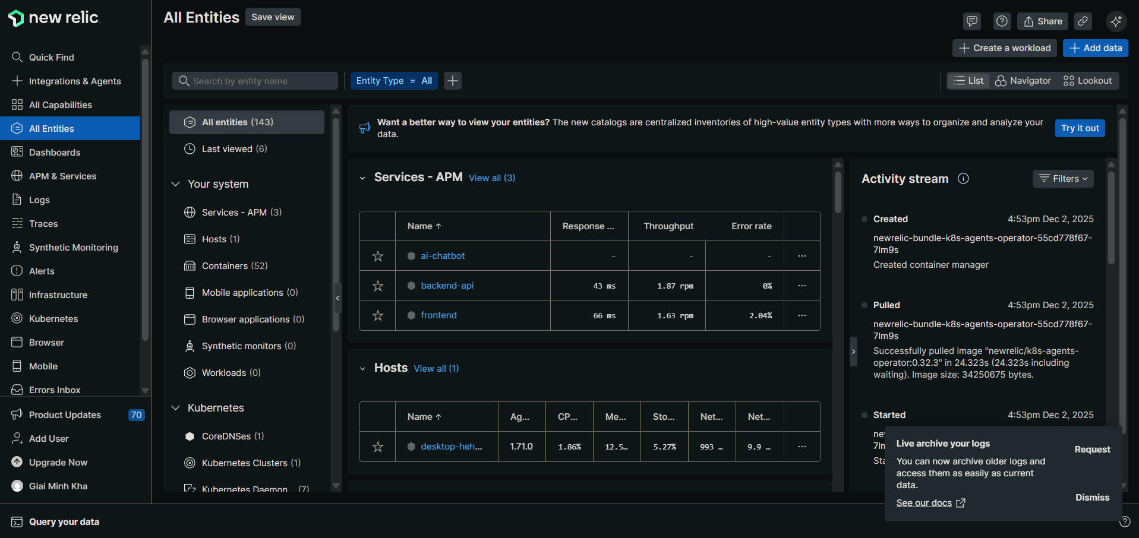

## New Relic APM & Services Detail View
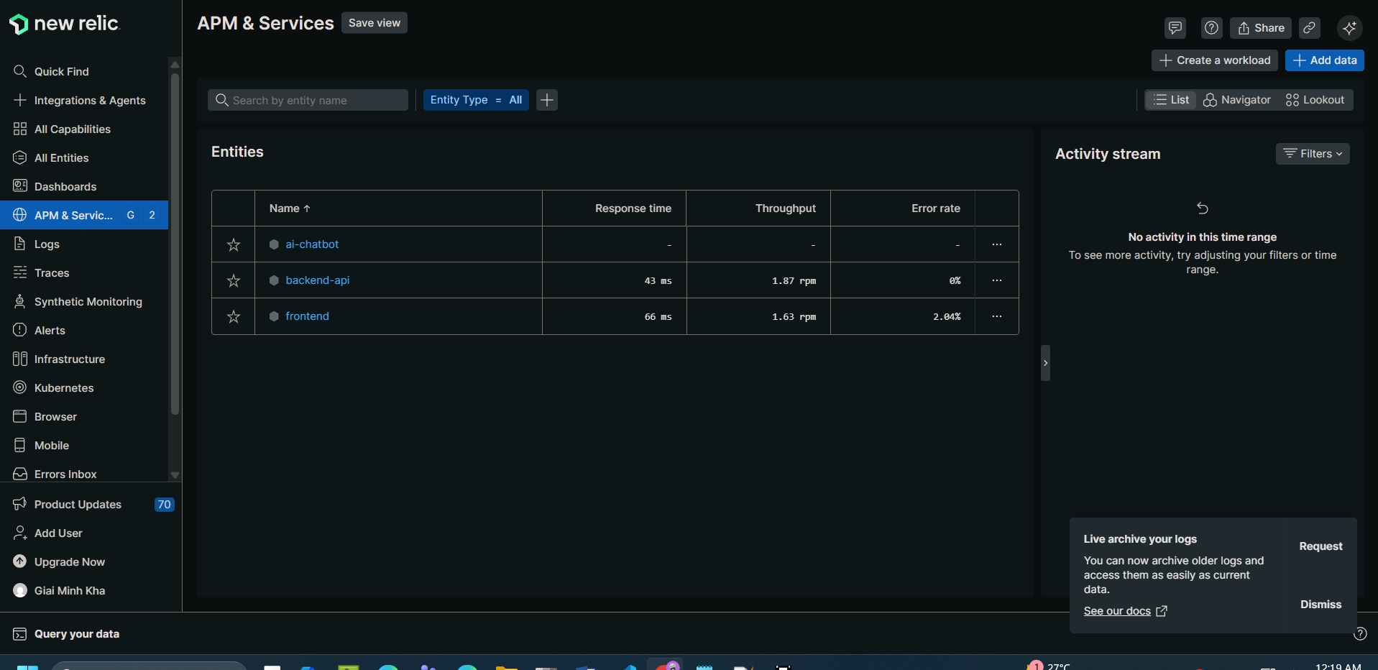

## Distributed Tracing
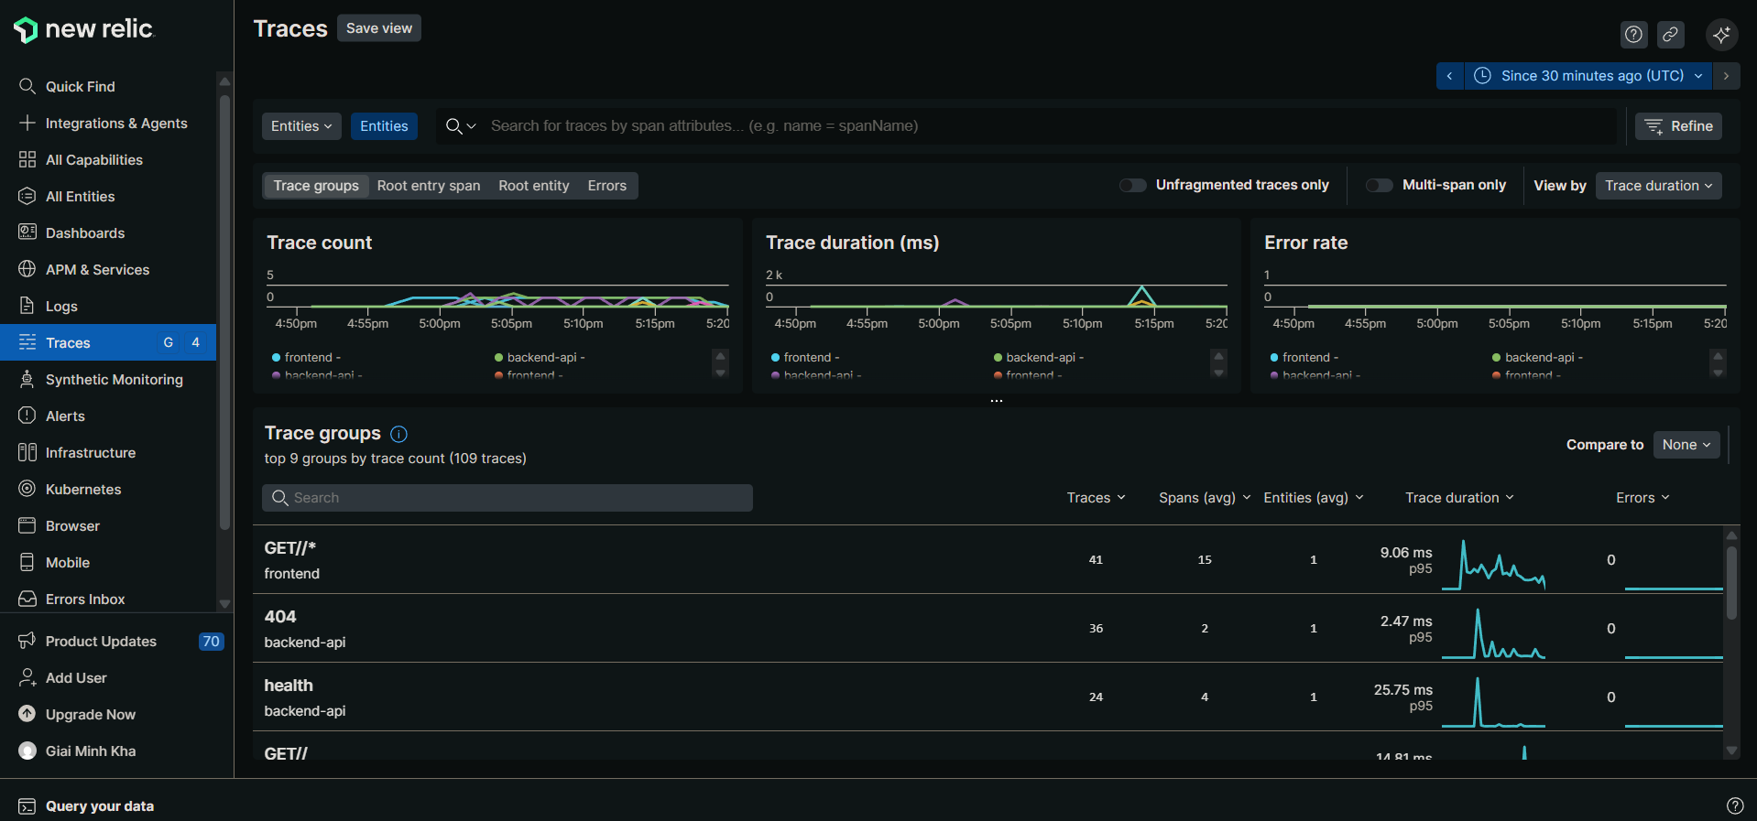
## Kubernetes Monitoring

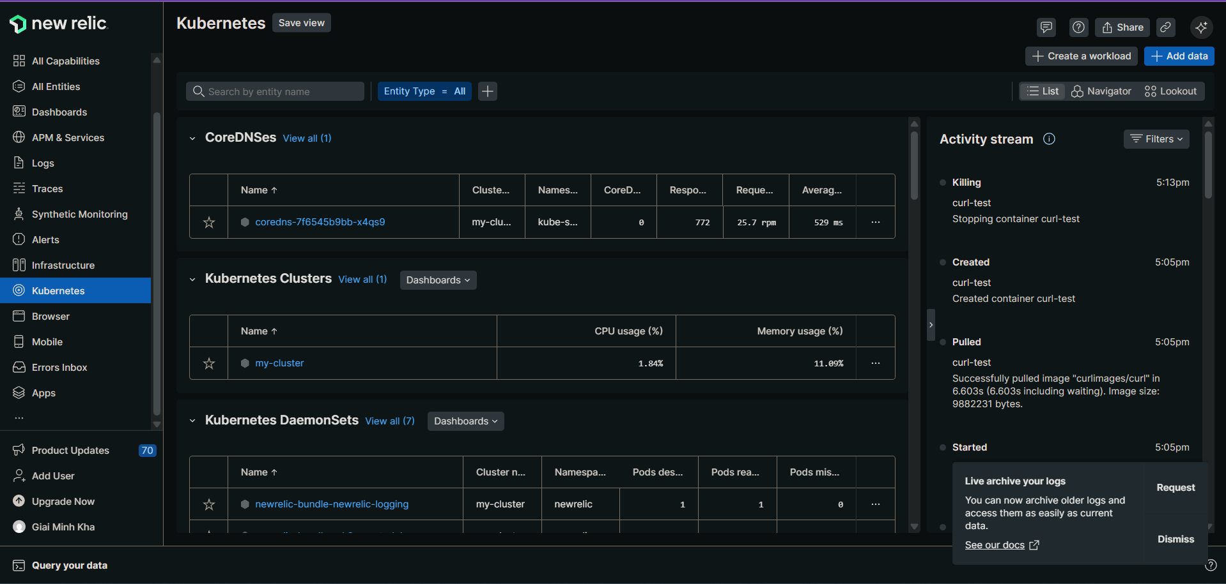

## AI Monitoring
## Dashboard
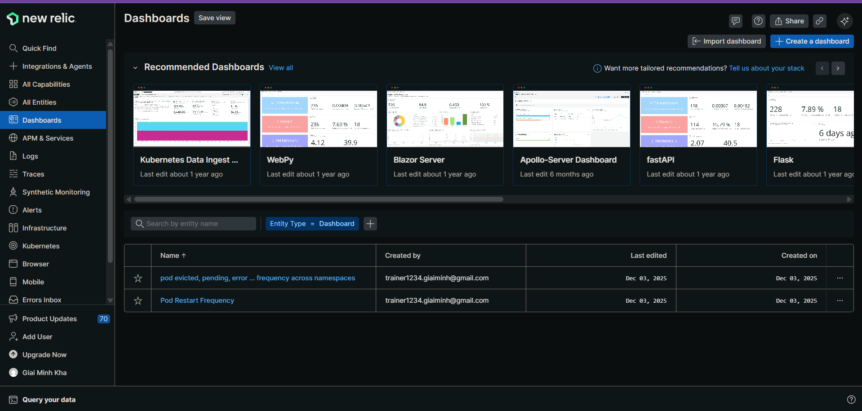
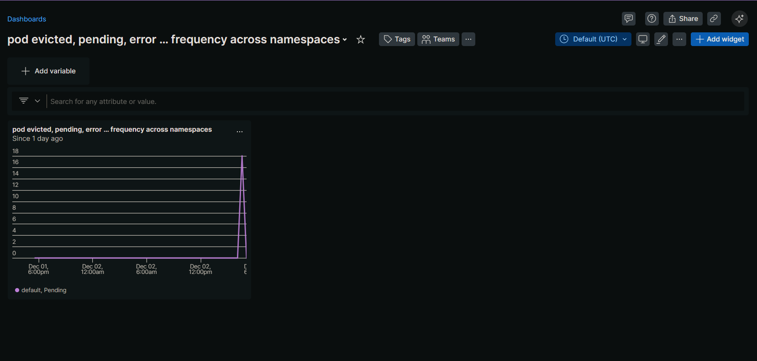
## Logs
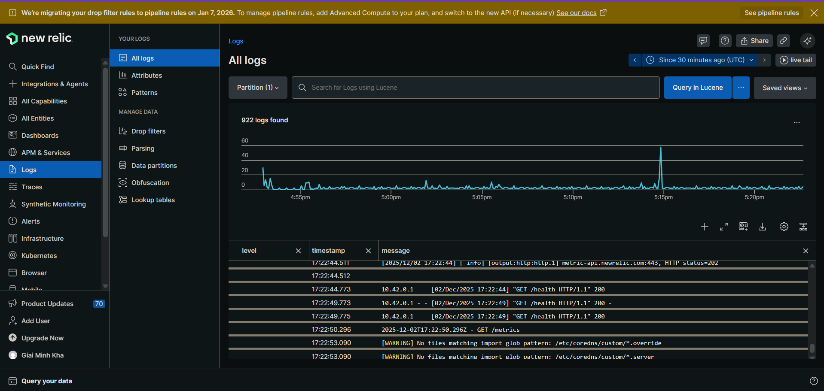
## Synthetic Checks
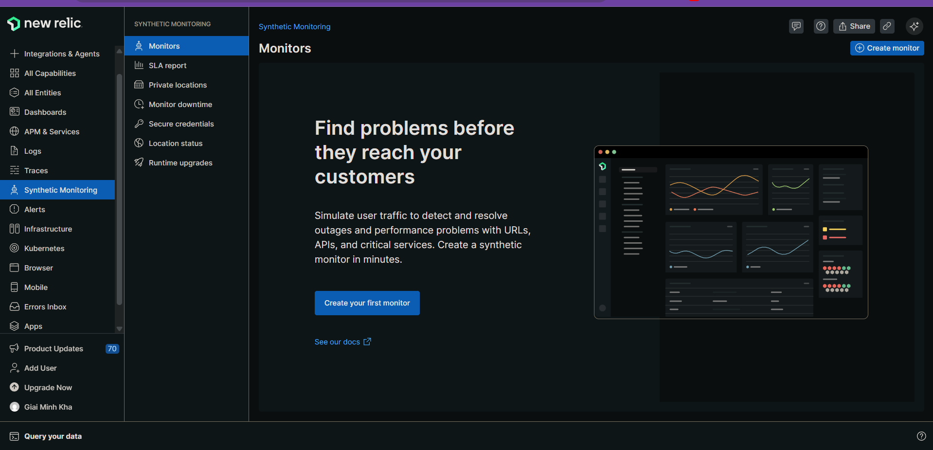
## Alerts
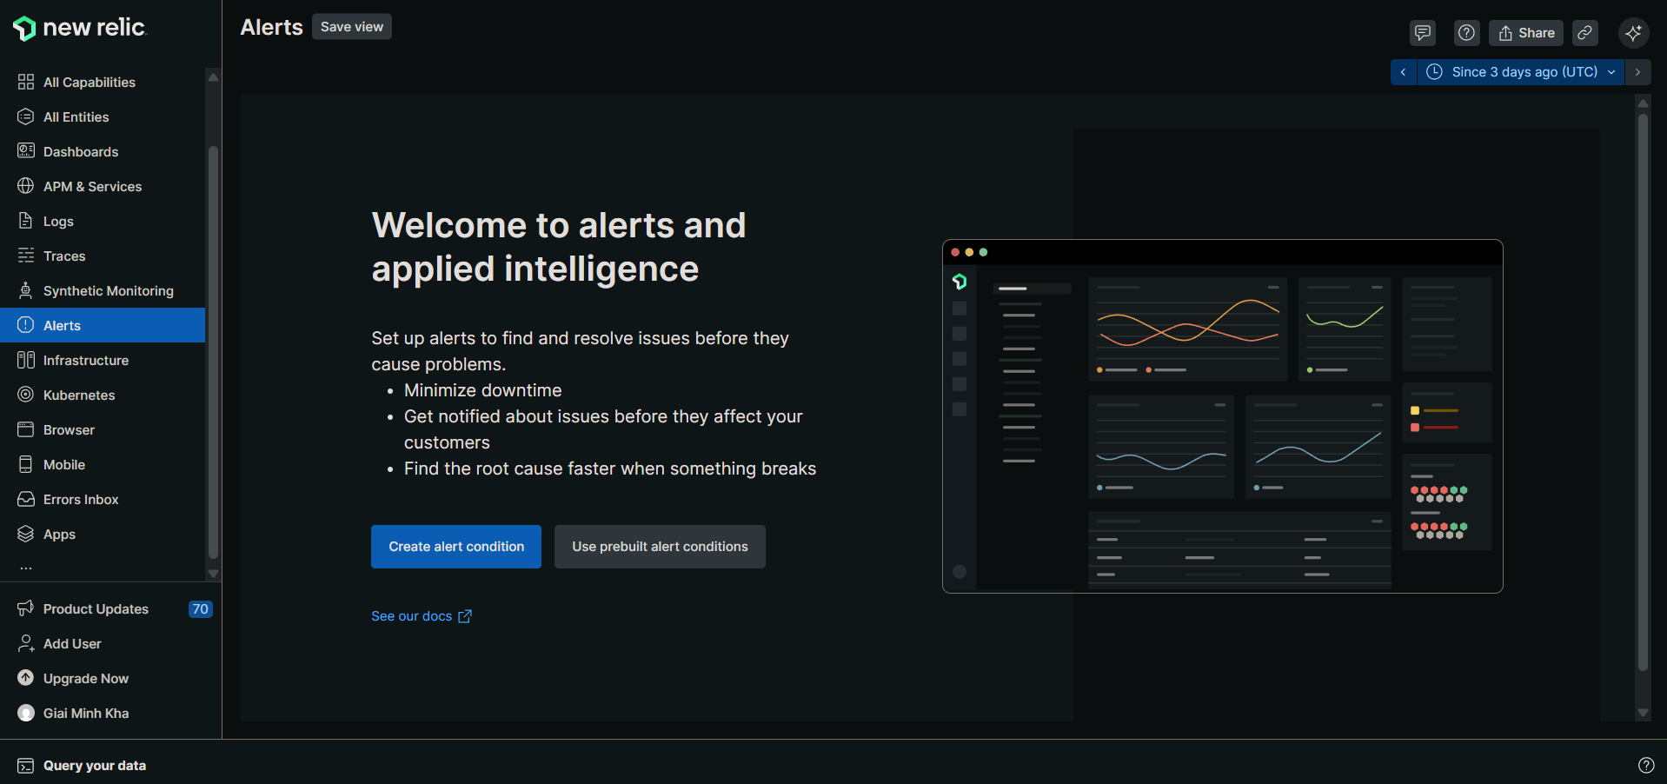

## Query your data
# Create a New Relic dashboard query to show pod evicted, pending, error … frequency across namespaces
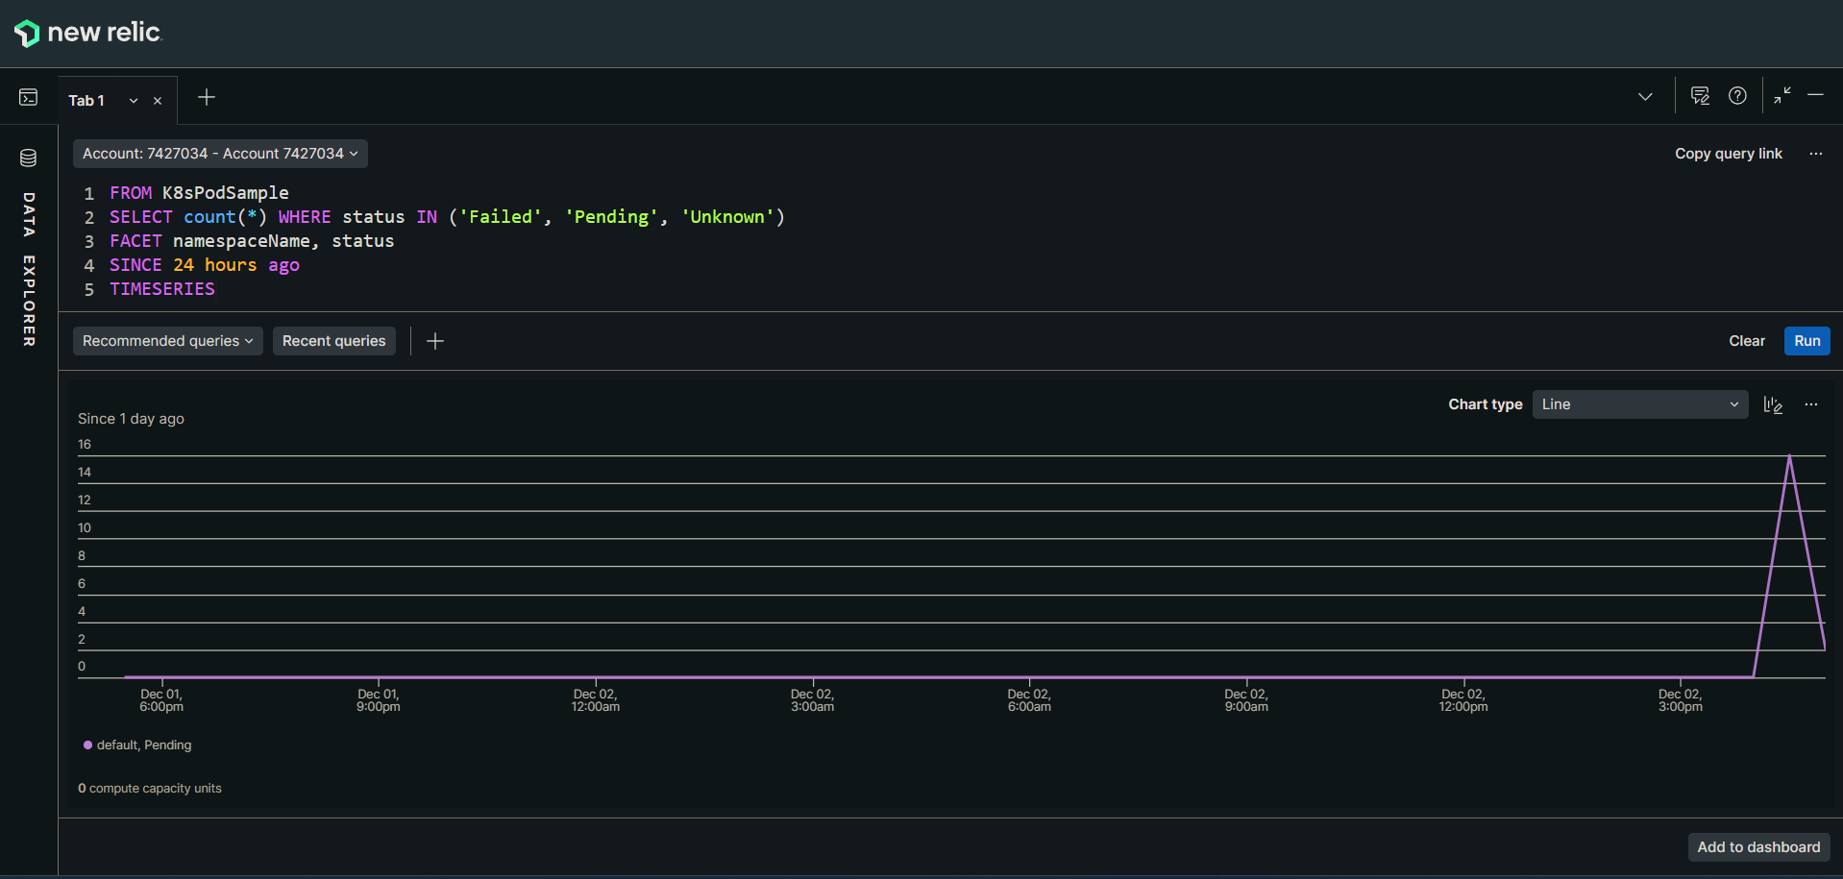
# Create a New Relic dashboard query to show pod restart frequency across namespaces
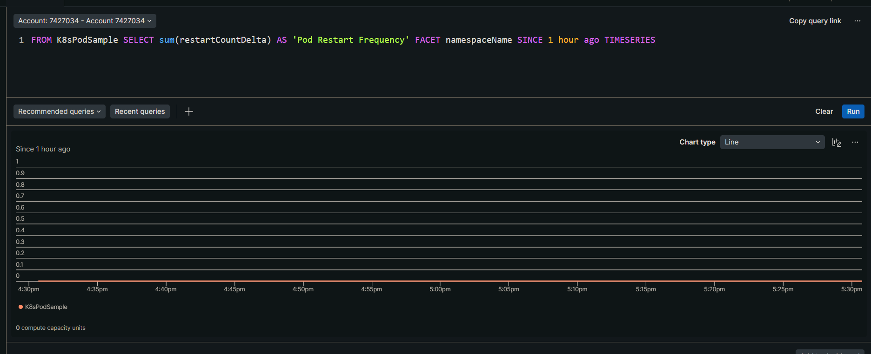
# How can I use New Relic to identify which pods are consuming the most memory in my cluster?
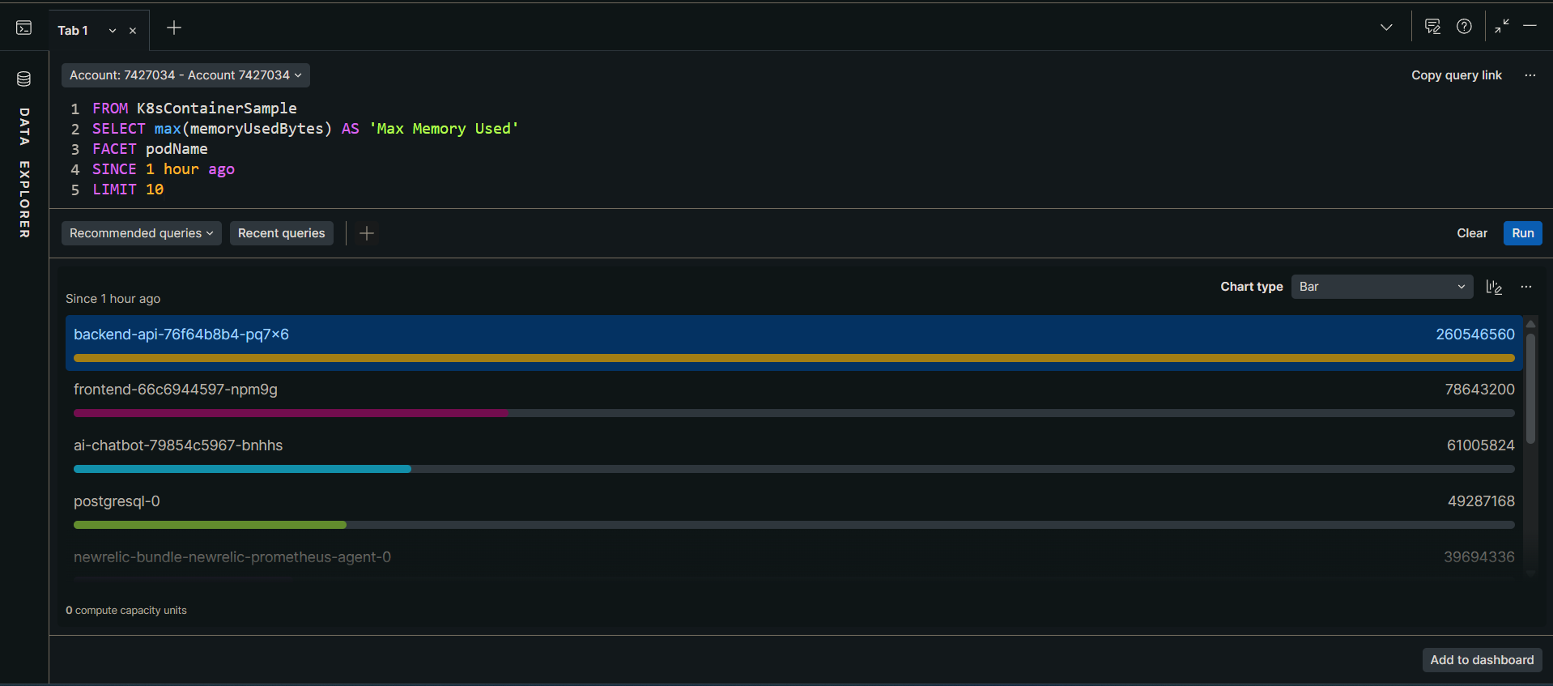
# My pods are experiencing high CPU usage. Help me analyze the metrics in New Relic
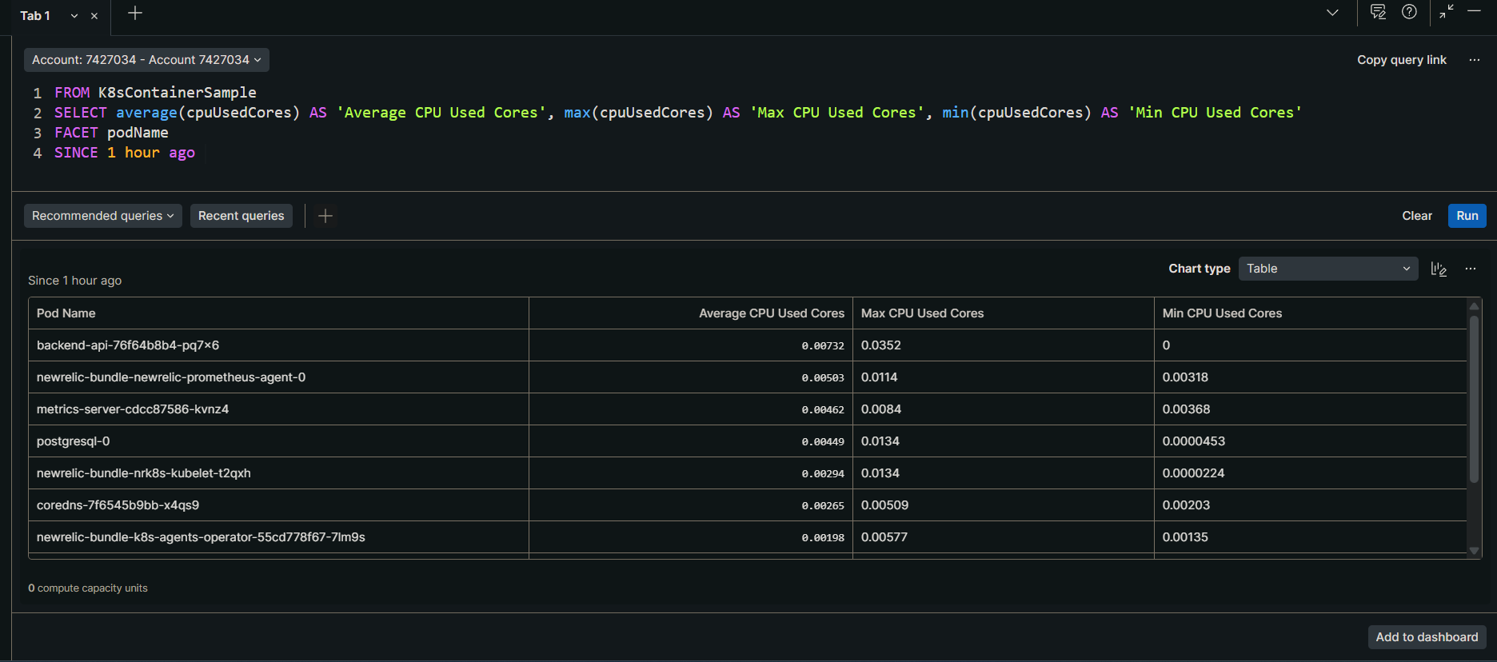
### I'm seeing increased error rates in my application. What's causing this and how can I fix it?
